# Anglers Camp

Institution: Dublin Business School

Course: Higher Diploma in Science in Computing

Stream: Software development

Interim Report

Name: Alexei Suleac

Email: [vasioki@gmail.com](mailto:vasioki@gmail.com)

Student ID: 10195788

Date: 28.05.2015

Supervisor: Niall Larkin

Contents

Acknowledgements 3

Introduction 3

Aims Of Project 3

Scope 3

Background 3

Context 3

Users 4

Specification and Design 4

Specification 4

Design 5

Project Evaluation 6

Demonstration of Progress 6

Future Work 7

Appendix 8

Wireframes 8

Screens 9

Code samples 10

Code sample 1 10

Code sample 2 11

# Acknowledgements

I would like to say thanks to Niall Larkin for advice on Demo using Azure and some general advice on the project I also would like to acknowledge Harnaik Dhoot as he gave some indications as to what kind of forum I could use for this project or use it as an idea on how to create my own.

# Introduction

## Aims Of Project

Project aim is to create a web app for coarse anglers in Ireland that would present a lot of useful information with the ability to register users and give them a possibility to communicate. Currently there are not that many web sites that give a lot of useful information to the anglers or give them the ability to communicate. There are plenty of web sites that would give general information on the region and what species you can catch there. A lot of information is scattered across many different sites. Every time when I plan and prepare for a fishing trip I have to look at many different web sites trying to find what are fishing conditions at the moment such as water levels and other conditions of the location. Water level in particular would be very important as this would determine if is possible to fish that particular lake or river at the time you are planning the trip

## Scope

The application will provide users with a platform to communicate and share their experiences. Provide users to view needed information in one place without having to search for it in multiple locations. The application will also provide the users with ability to plan their fishing trips based on water levels for venues, past fishing reports for that location that were submitted by other users or current user. Activity of different fishing clubs will also be facilitated by the applications, users will be able to create their own fishing clubs, join other fishing clubs and plan trips with other members.

# Background

## Context

For people that enjoy fishing it is very important to plan their fishing trips appropriately as poor planning can potentially ruin the whole experience. A good example of this would be a person arriving on a bank of a river or lake and find that access to the swims is restricted due to very high water levels.

With the help of few web API’s and technologies available to us we can build an application that could help anglers in Ireland to plan their trips properly and enjoy their trips.

At the moment there are no web sites or apps that would offer users the ability to plan their trips appropriately any information that is available users have to gather from many different web sites and the fishing season is starting very soon that’s why it is a good idea to build such an application for users at this moment.

## Users

Typical users of the system would be course anglers mostly male. There currently no water level sensors for sea fishing locations so the app would target course anglers. One potential downside is that many anglers are people that are usually not very keen on technology so user interaction will have to be made as simple as possible.

# Specification and Design

## Specification

The web application will have seven pages : Home, Venues, Profile, Reports, Forum, Clubs, Login/Register(Please see the wireframes for this project attached).

There are three different groups of users identified for this application: Admin, Member, Non-Member every user can have different requirements.

**Admin** – Should be able to edit the value of acceptable water levels, edit posts on forums and remove inappropriate content.

**Members** – should be able record their past fishing trips and should be able to store them, following information is required: Date, Location, Tactics used, caught species, picture and member ID and it should be kept private or shared with other members. Member should be able to create a fishing club and invite other members of the site to join their club they should also be able to join other clubs. Member should be able to create a discussion topic on the forum and leave comments also. Members should be able to update their profile and change details such as email or picture. New members by default are not members of any fishing club.

**Admin/Members** – should be able to log in or out of the system, should be able to view fishing trip reports.

**Non-Members** – Should be able to register

**All users** – should be able to view information provided on the home page, be able to view fishing locations with water levels and if the location is fishable or not.

Following us the use case diagram created for this application.



## Design

The data necessary for the application would be stored in MS SQL database. Following are the entities that will need to be stored in the database were identified: WaterLevel, Member, Club and Report.



For this project I decided to use ASP.NET MVC with the use of n-tiered architecture. At present I have split the application in to 4 different layers: Presentation layer, Busyness object layer(BOL), Busyness Logic Layer(BLL) and Data Access Layer(DAL). For database access from DAL I use Entity Frameworks.

# Project Evaluation

Overall I am happy with my initial design and would not make many changes. Choosing ASP.NET MVC as a technology to implement the solution for this project is a good choice in my opinion as this will give me a chance to learn new technology and be able to create something useful with it.

Only downside at the moment is that I don’t have much experience with ASP.NET MVC so the project initially took more time than I anticipated

# Demonstration of Progress

All the wireframes and diagrams for this project are included in the appendix.

From the specification of the project it can be seen that requirements are gathered and understood. At the moment I was able to create a general layout page that I can use for all the pages in my application (_Layout.cshtml) this is equivalent to master pages in web apps that are developed with web forms. I was also able to create my man page with slider and tree placeholders for the content (please see the screenshot provided) in MVC this is called a view so every page I need to create a different view. Please see code sample1 and code sample 2 provided in the appendix for these pages (I will not include C# code as this will require a lot of space).

Please NOTE: I wasn’t able to upload the project to Azure yet for working demo but will do that shortly.

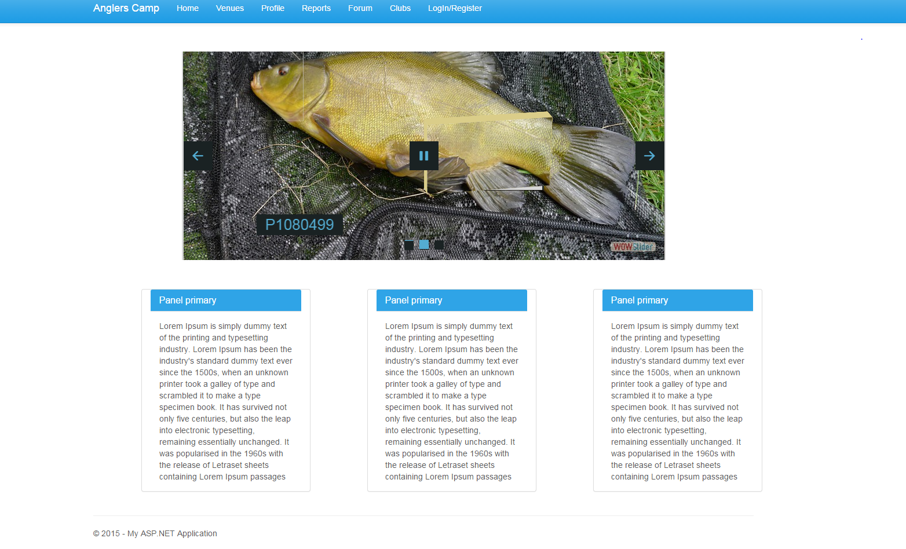

# Future Work

At the moment I am a bit behind the original project schedule and this is due to the fact that I had to study MVC and I had to complete a course on it before I could start doing anything.

But I was still able to complete the master page and initial design of the web site, the only things I was not able to do to date was starting to implement use cases but should be able to start working on it within next few days. So even though I wasn’t able to complete everything as planned I am confident that I will be able to catch up and no changes to the plan will be necessary.

*Word Count - [1220]*

# Appendix

## Wireframes

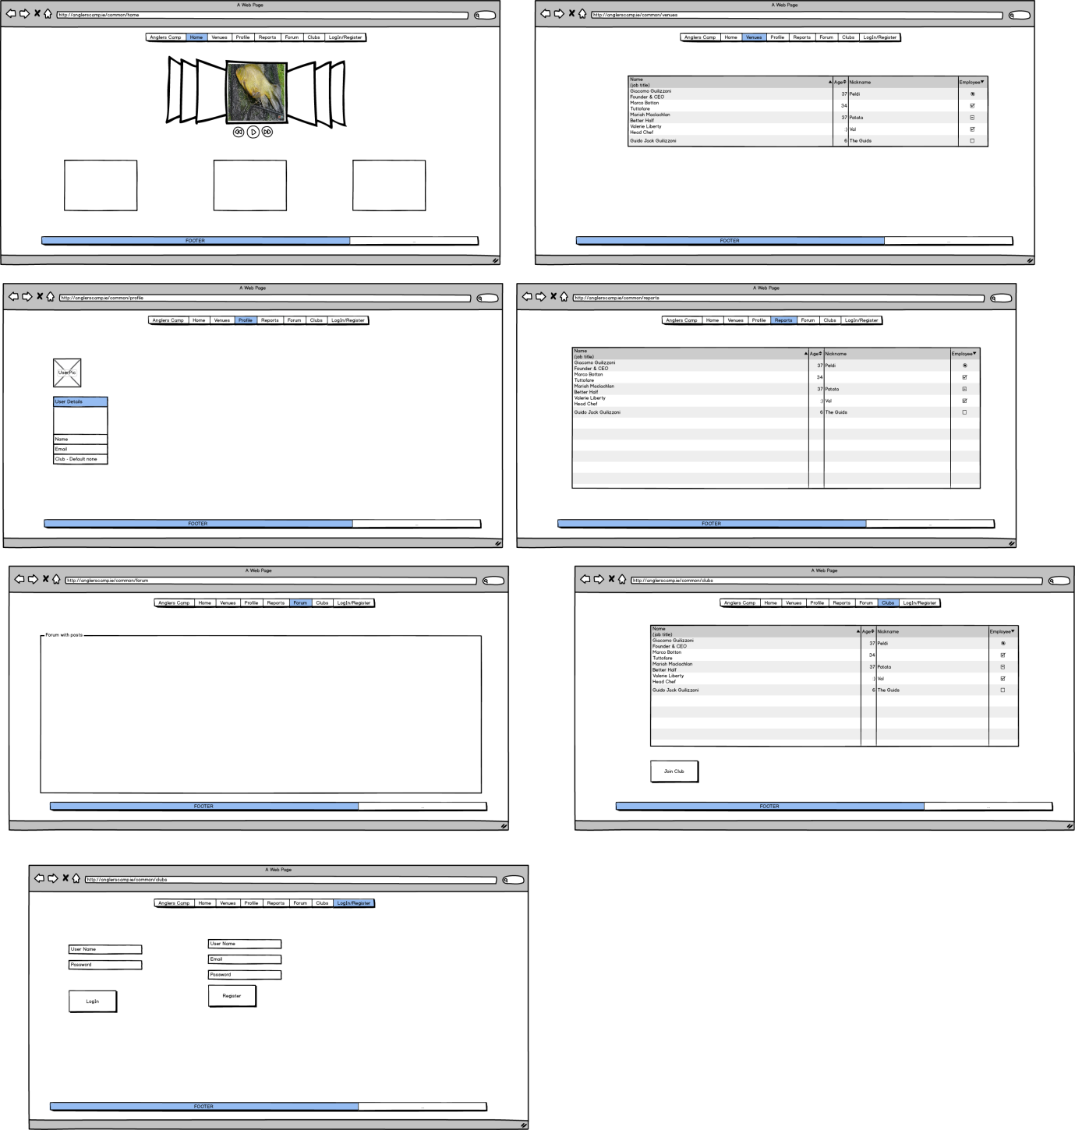

## Screens

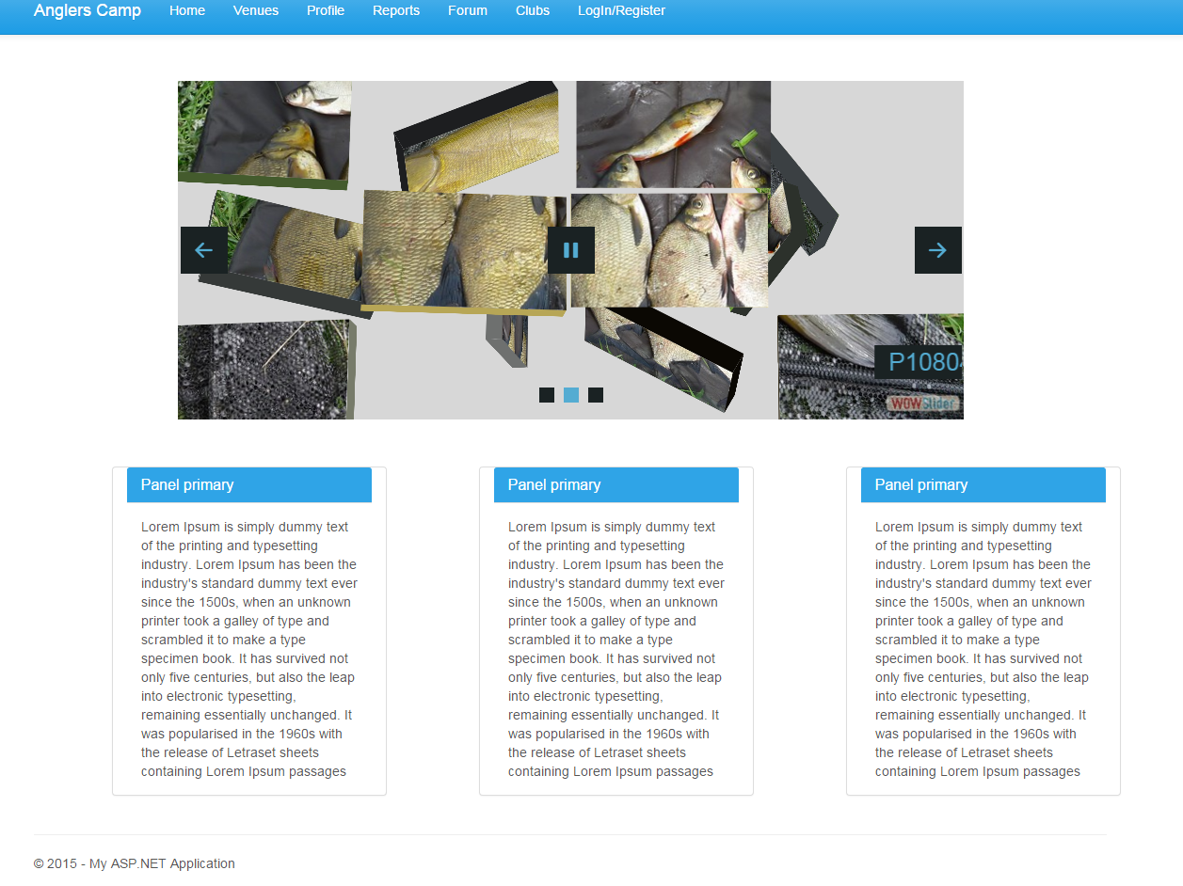

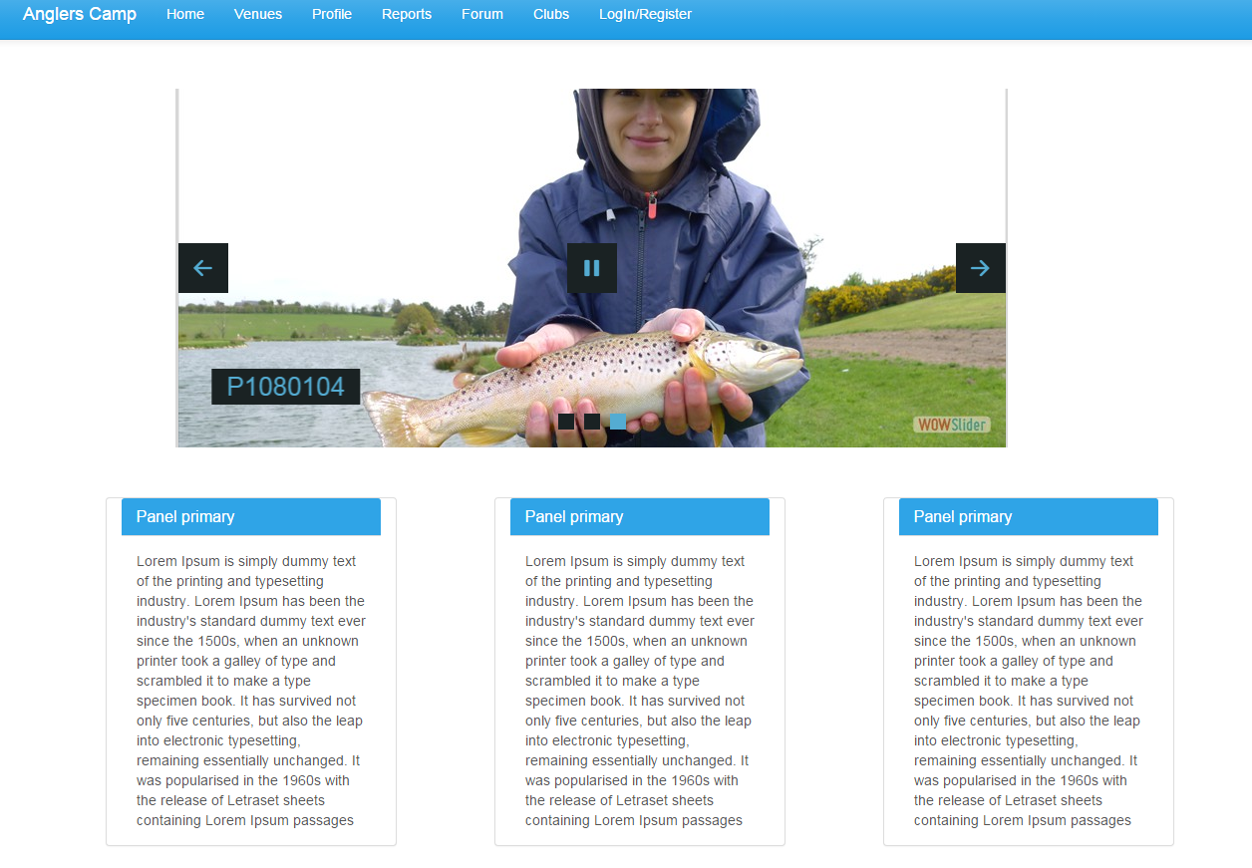

## Code samples

### Code sample 1

*Code for _Layout.cshtml*

<!DOCTYPE html>

<html>

<head>

<meta charset="utf-8" />

<meta name="viewport" content="width=device-width, initial-scale=1.0">

<title>@ViewBag.Title - Anglers Camp</title>

<link href="~/Content/Site.css" rel="stylesheet" type="text/css" />

@*<link href="~/Content/bootstrap.min.css" rel="stylesheet" type="text/css" />*@

<link href="~/Content/bootstrap.css" rel="stylesheet" />

<script src="~/Scripts/modernizr-2.6.2.js"></script>

</head>

<body>

<div class="navbar navbar-default navbar-fixed-top">

<div class="container">

<div class="navbar-header">

<button type="button" class="navbar-toggle" data-toggle="collapse" data-target=".navbar-collapse">

<span class="icon-bar"></span>

<span class="icon-bar"></span>

<span class="icon-bar"></span>

</button>

@Html.ActionLink("Anglers Camp", "Index", "Home", new { area = "Common" }, new { @class = "navbar-brand" })

</div>

<div class="navbar-collapse collapse">

<ul class="nav navbar-nav">

<li>@Html.ActionLink("Home", "Index", new { Controller = "Home", Area = "Common" })</li>

<li>@Html.ActionLink("Venues", "Index", new { Controller = "Venues", Area = "Common" })</li>

<li>@Html.ActionLink("Profile", "Index", new { Controller = "Profile", Area = "Member" })</li>

<li>@Html.ActionLink("Reports", "Index", new { Controller = "Reports", Area = "Common" })</li>

<li>@Html.ActionLink("Forum", "Index", new { Controller = "Forum", Area = "Member" })</li>

<li>@Html.ActionLink("Clubs", "Index", new { Controller = "Clubs", Area = "Common" })</li>

<li>@Html.ActionLink("LogIn/Register", "Index", new { Controller = "LogIn/Register", Area = "Common" })</li>

</ul>

</div>

</div>

</div>

<div class="container body-content">

@RenderBody()

<hr />

<footer>

<p>&copy; @DateTime.Now.Year - My ASP.NET Application</p>

</footer>

</div>

<script src="~/Scripts/jquery-1.10.2.min.js"></script>

<script src="~/Scripts/bootstrap.min.js"></script>

</body>

</html>

### Code sample 2

*Code for main or home page view*

@{

ViewBag.Title = "Index";

Layout = "~/Views/Shared/_Layout.cshtml";

}

<h2></h2>

<iframe src="~/Index.html" style="width:835px; height:360px; max-width:100%; overflow:hidden; border:none;padding:0; margin: 0 auto;margin-top:100px; margin-bottom:50px; display:block;" marginheight="0" marginwidth="0"></iframe>

<div class="row">

<div class="col-md-1"></div>

<div class="panel panel-primary col-md-3">

<div class="panel-heading">

<h3 class="panel-title">Panel primary</h3>

</div>

<div class="panel-body">

Lorem Ipsum is simply dummy text of the printing and typesetting industry. Lorem Ipsum has been the industry's standard dummy text ever since the 1500s, when an unknown printer took a galley of type and scrambled it to make a type specimen book. It has survived not only five centuries, but also the leap into electronic typesetting, remaining essentially unchanged. It was popularised in the 1960s with the release of Letraset sheets containing Lorem Ipsum passages

</div>

</div>

<div class="col-md-1"></div>

<div class="panel panel-primary col-md-3">

<div class="panel-heading">

<h3 class="panel-title">Panel primary</h3>

</div>

<div class="panel-body">

Lorem Ipsum is simply dummy text of the printing and typesetting industry. Lorem Ipsum has been the industry's standard dummy text ever since the 1500s, when an unknown printer took a galley of type and scrambled it to make a type specimen book. It has survived not only five centuries, but also the leap into electronic typesetting, remaining essentially unchanged. It was popularised in the 1960s with the release of Letraset sheets containing Lorem Ipsum passages

</div>

</div>

<div class="col-md-1"></div>

<div class="panel panel-primary col-md-3">

<div class="panel-heading">

<h3 class="panel-title">Panel primary</h3>

</div>

<div class="panel-body">

Lorem Ipsum is simply dummy text of the printing and typesetting industry. Lorem Ipsum has been the industry's standard dummy text ever since the 1500s, when an unknown printer took a galley of type and scrambled it to make a type specimen book. It has survived not only five centuries, but also the leap into electronic typesetting, remaining essentially unchanged. It was popularised in the 1960s with the release of Letraset sheets containing Lorem Ipsum passages

</div>

</div>

<div class="col-md-1"></div>

</div> @*End of row*@